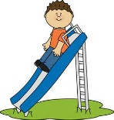
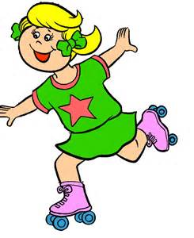
Dear Parents,

Attached you will find a cutout of a body for your child to decorate to look like themselves. Please use any art supplies that you may have at home (felt, yarn, fabric, construction paper, buttons, dry foods, etc.) to put hair, a face, clothes, shoes, etc. on the body. Have fun and be as creative as you would like to be. You may decorate the front and back of your person.

Also, please complete the “All About Me” writing. Have your child fill this out in their own handwriting. You may help them with all of the spelling. Send in writing as is with the decorated cutout body by _____________________.

Thank you,
The First Grade Teachers
--------------------------------------------------------------------------------------------

“All About Me”

My name is ______________________________________.
I am _______________ years old.
I have ____________________ hair.
My eyes are ______________________.
I am _______________ inches tall.
I like to ________________________________________.

